Birmingham, AL – Research Insights (Spring ‘25)

1. Unemployment Is Higher Than Average: Birmingham's unemployment rate is approx 4.3%, which is higher than that of Alabama's average of 3.6% overall but less than it was in the years before.

2. Rent Is Increasing: A one-bedroom apartment's average rent is $1,040, which is around 7% more than it was a year ago. The rate of vacancy is nearly 6.5%.

3. The problem of rent burden is important: 42% of renters spend more than 30% of their income on housing.

4. Not enough Affordable Housing: For it to keep up with demand, Birmingham needs at least 10,000 more affordable housing units.

5. Eviction Rates Stay High: Alabama has weak tenant protections, and eviction rates are around 5.6%, far higher than the national average.

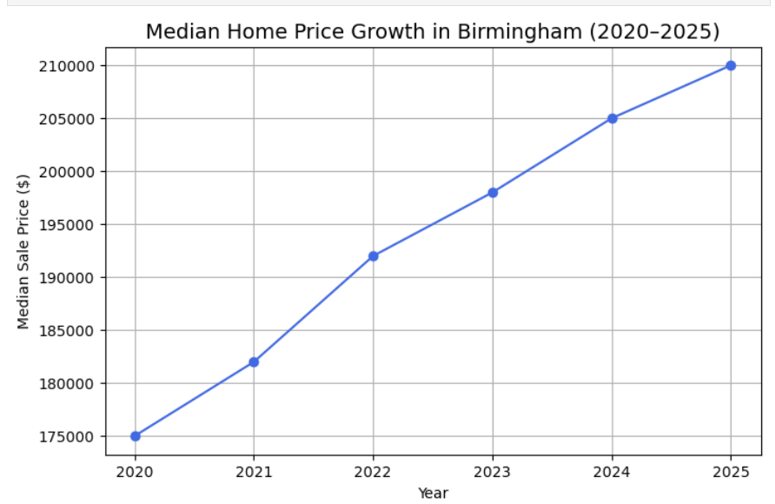 We can see how the median home sale price grew by almost 20%, from around $175,000 in 2020 to about $210,000 in 2025. The most drastic rise happened between 2021 and 2022, when prices surged quickly due to a significant spike in demand. Since then, prices have increased annually, albeit a little more slowly. Although this steady upward trend points to a generally strong housing market, it also draws attention to the developing affordability issues, particularly given that Birmingham's income levels have not increased at the same rate.
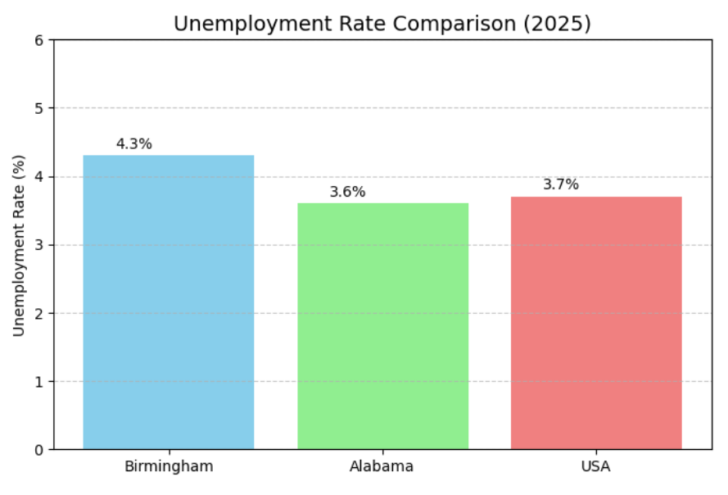

6. Low-Income Neighborhoods Have Difficulties: Ensley, West End, and North Birmingham are some of the neighborhoods that struggle with higher housing instability and rates of poverty above 30%.
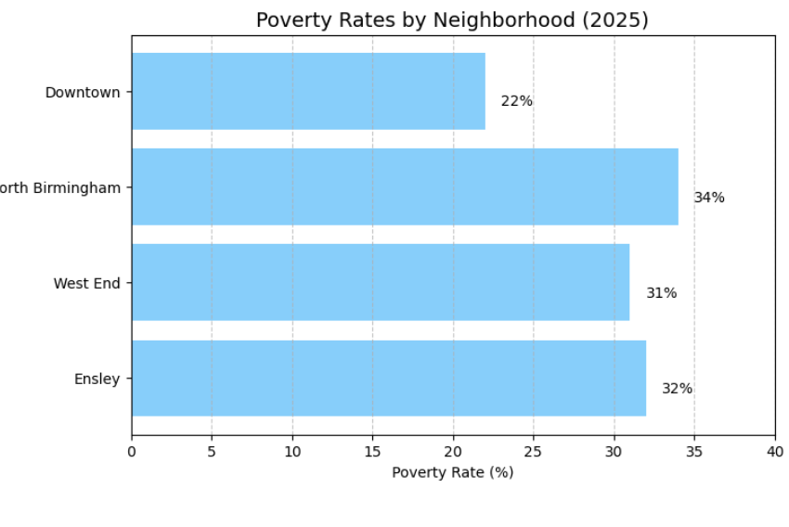

7. No Citywide Inclusionary Zoning: While there are local efforts like the Affordable Housing Trust Fund, there is no official law requiring affordable housing.

8. Downtown Gentrification: As the region around UAB grows, rents in communities like Avondale and Lakeview are rising.

9. Housing prices Are Growing More Rapidly Than Income: Although the median household income is $55,000, housing prices are rising more quickly.

10. Higher Default Rates in Certain ZIP Codes: The greatest predicted default rates (~7.2%) are found in ZIP codes like 35211 and 35208.

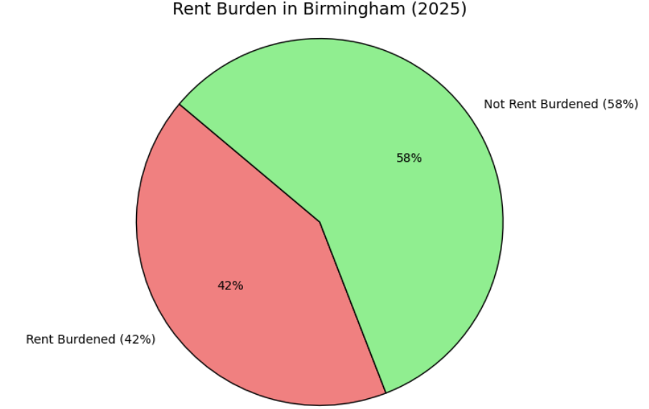

11.Median Sale Price: ~$210,000 (up 6–7% year-over-year)
Sale-to-List Price Ratio: Homes are selling for about 96% of list price.
Days on Market: Homes sell in about 48 days — faster than the national average.
Neighborhood Trends:
- Big price jumps (~10–12%) in Avondale, Lakeview, and downtown areas.
- Most affordable areas: Ensley, North Birmingham, East Lake — but with higher vacancy risks.

Sources:
- https://acre.culverhouse.ua.edu/housing-reports/
- https://bhauthority.org/-City of Birmingham Housing Reports
- https://www.alabamapolicy.org/
- sales_AL.xlsx (March 2025)a

